**Name:-** Om Talekar.

**Email :-** omtalekar0123@gmail.com

**Power BI :- Task 1.**

**Dataset :-** Exhaustive Analysis of Indian Agriculture

**Step 1 :-** Load Dataset.

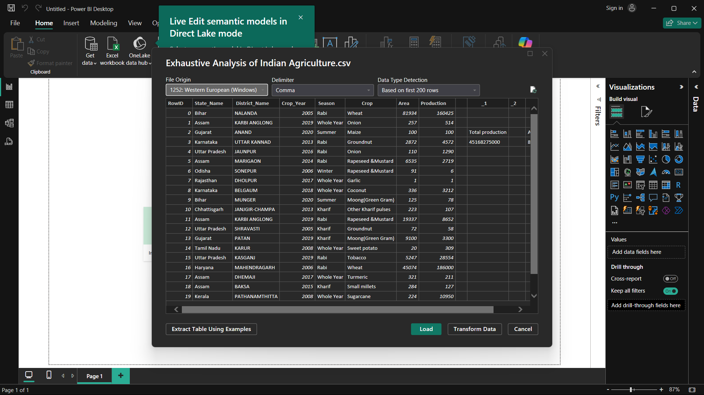

**Step 2 :-** **i). Report Views.**

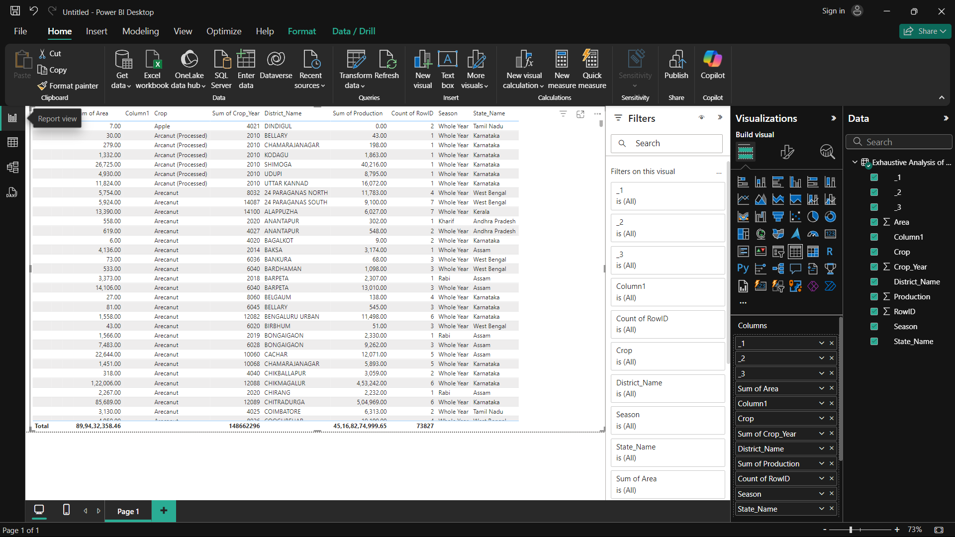

**ii).Table views .**

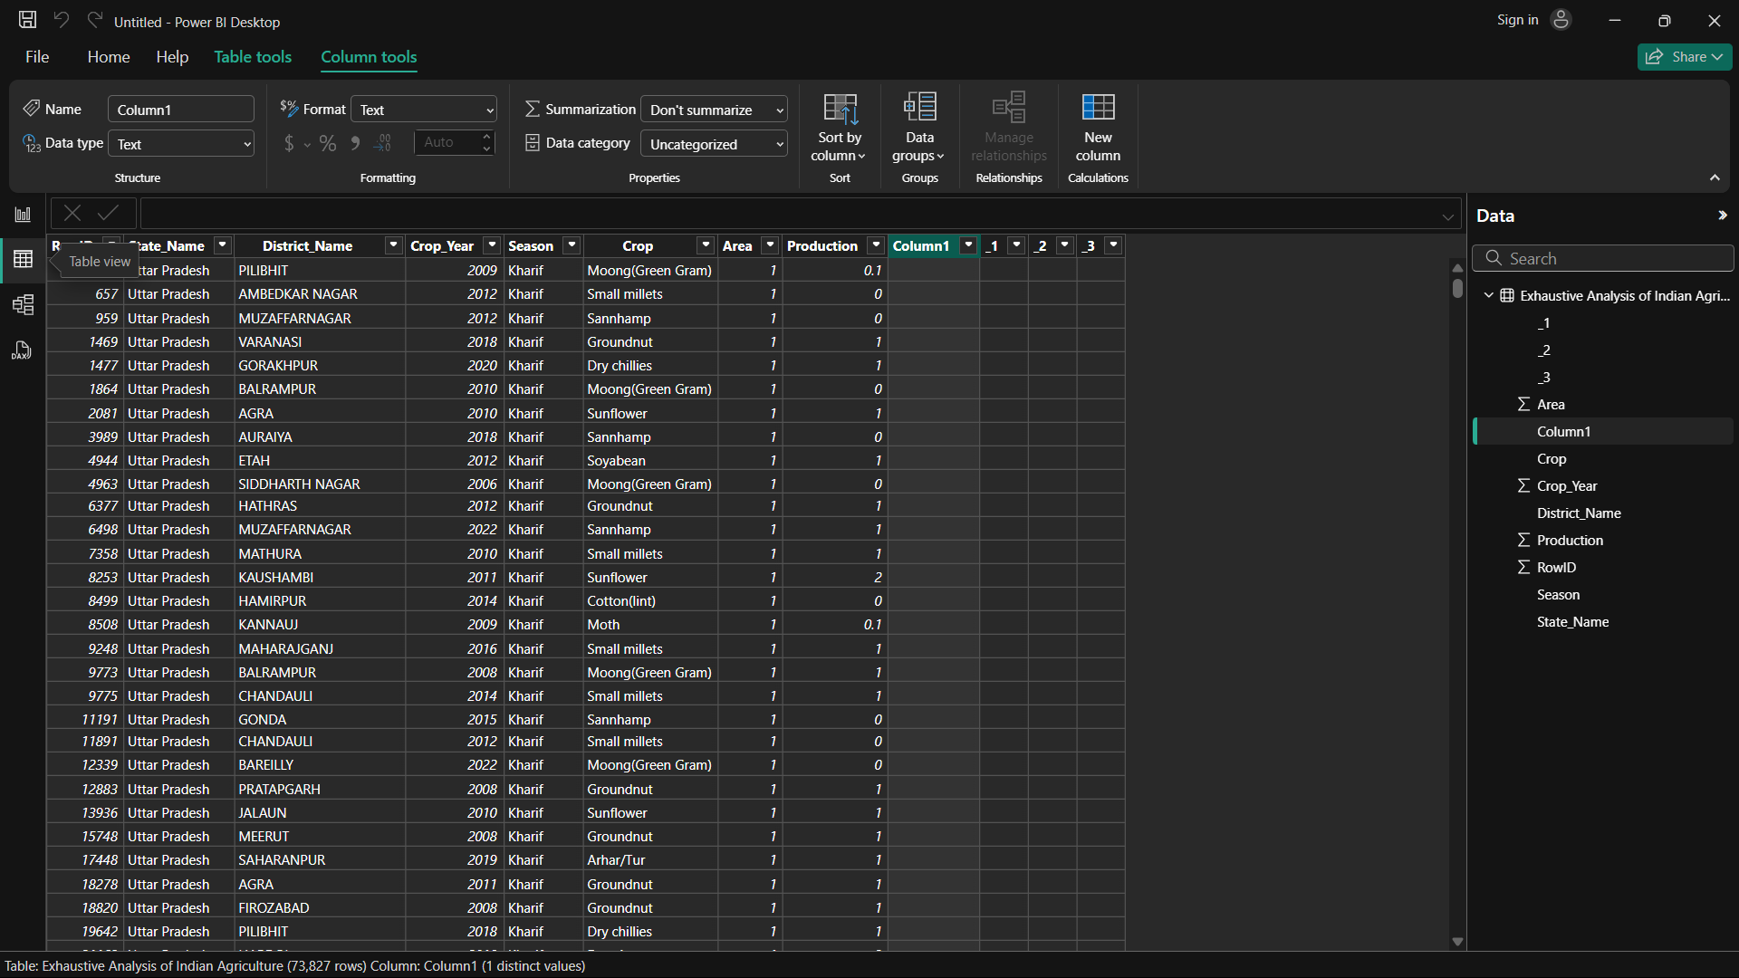

**iii). Model Views.**

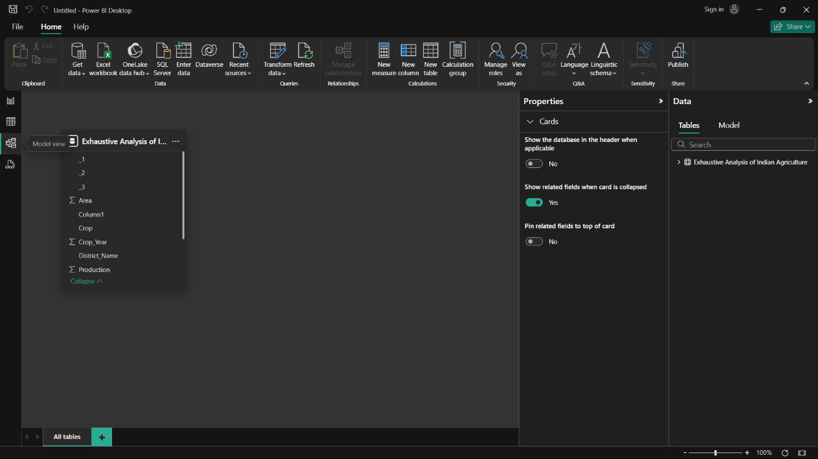

**Step 3 :-** Transform Dataset.

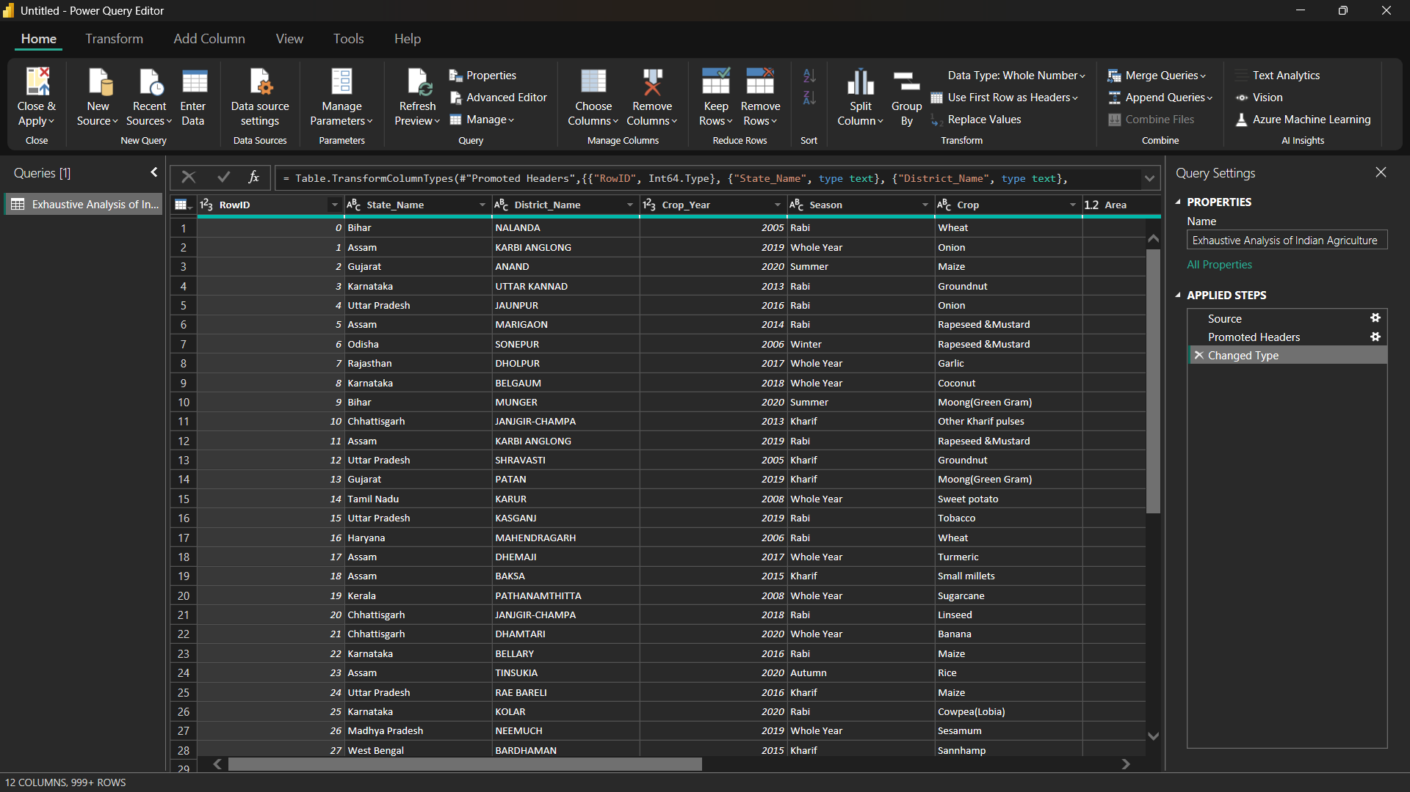

**Step 4 :-** Column removing .

**i). Before column removing.**

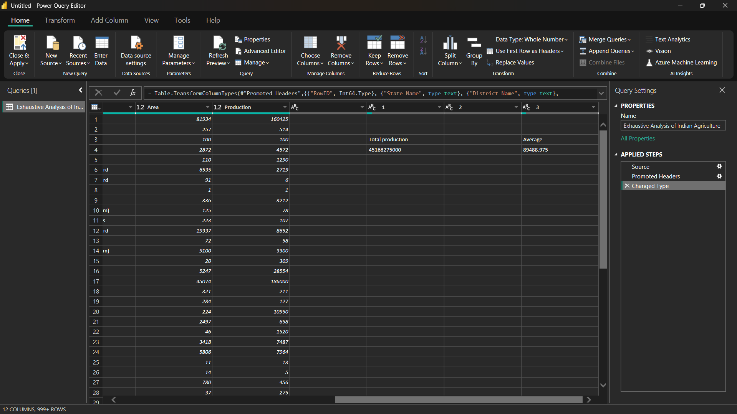

**ii). After column removing.**

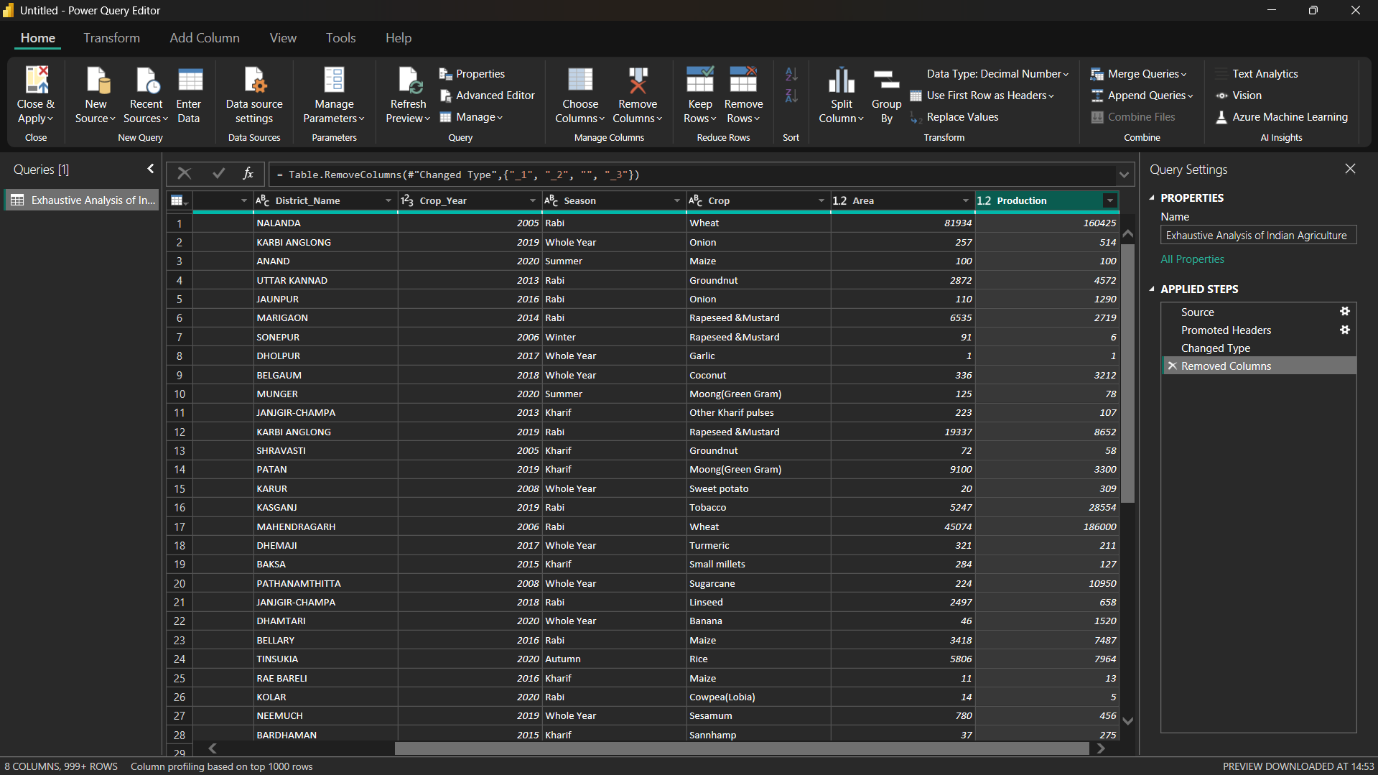

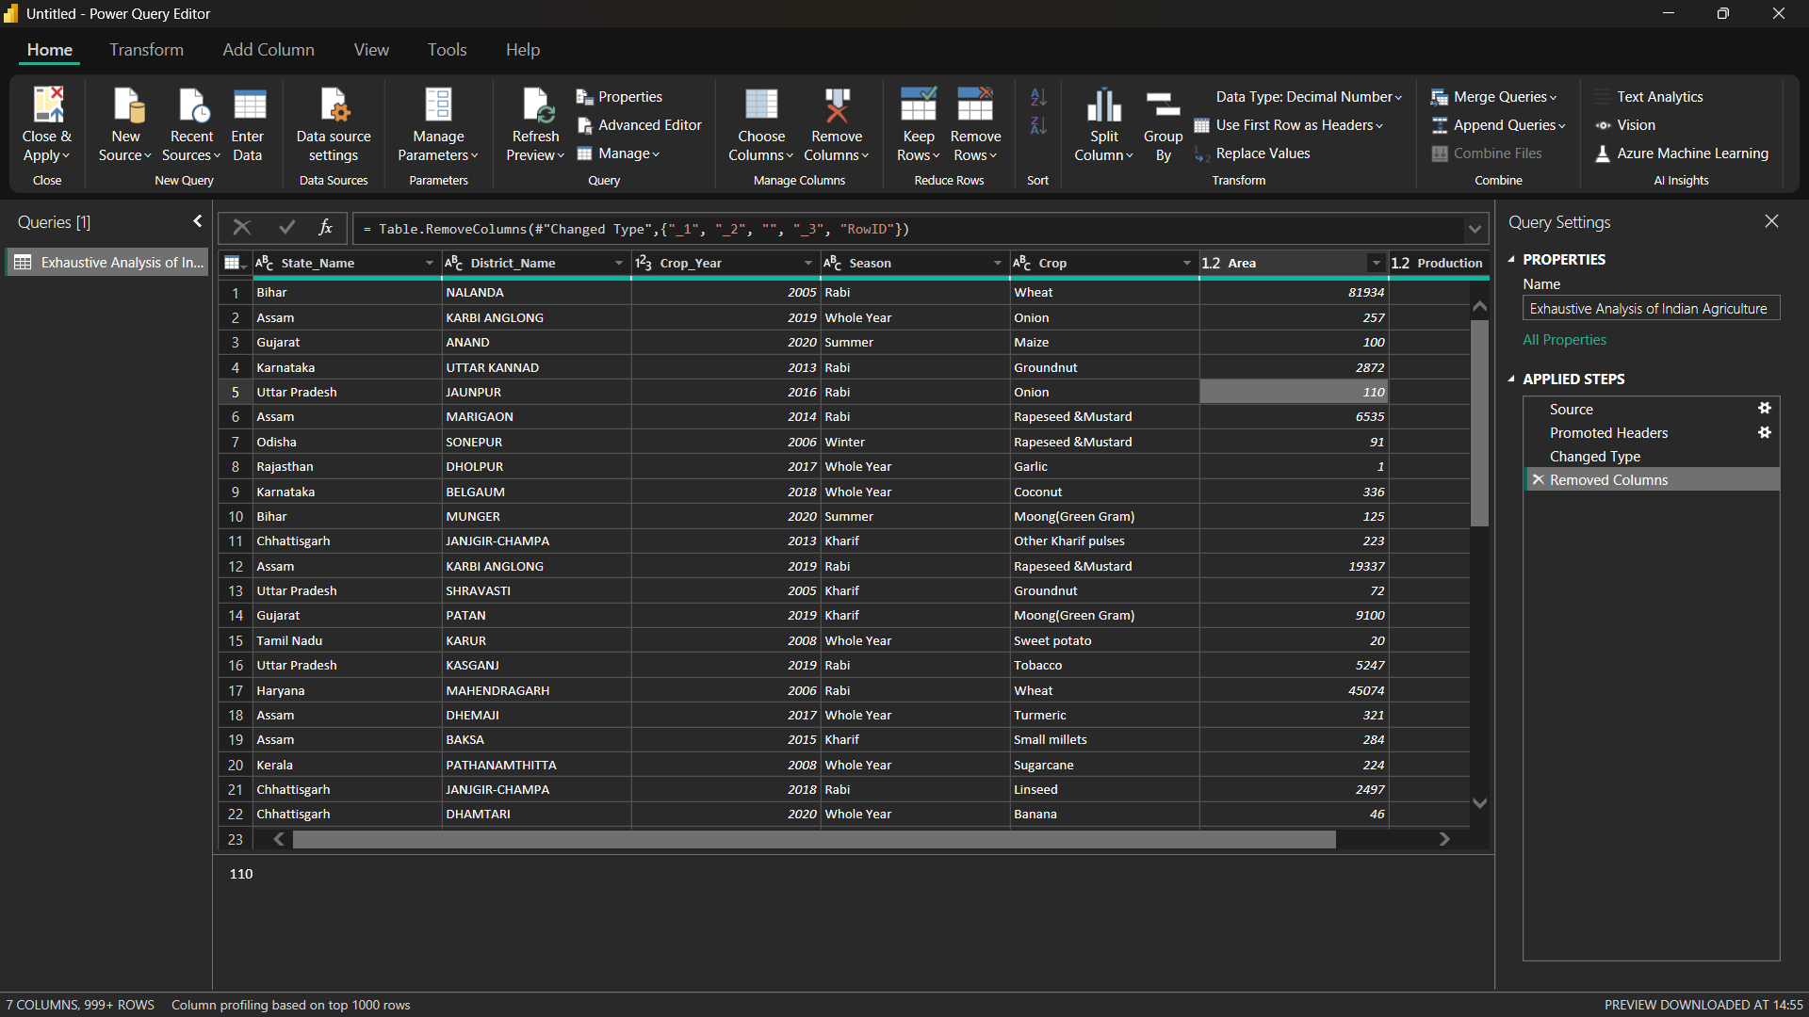

**Step 5 :-** Column Quality.

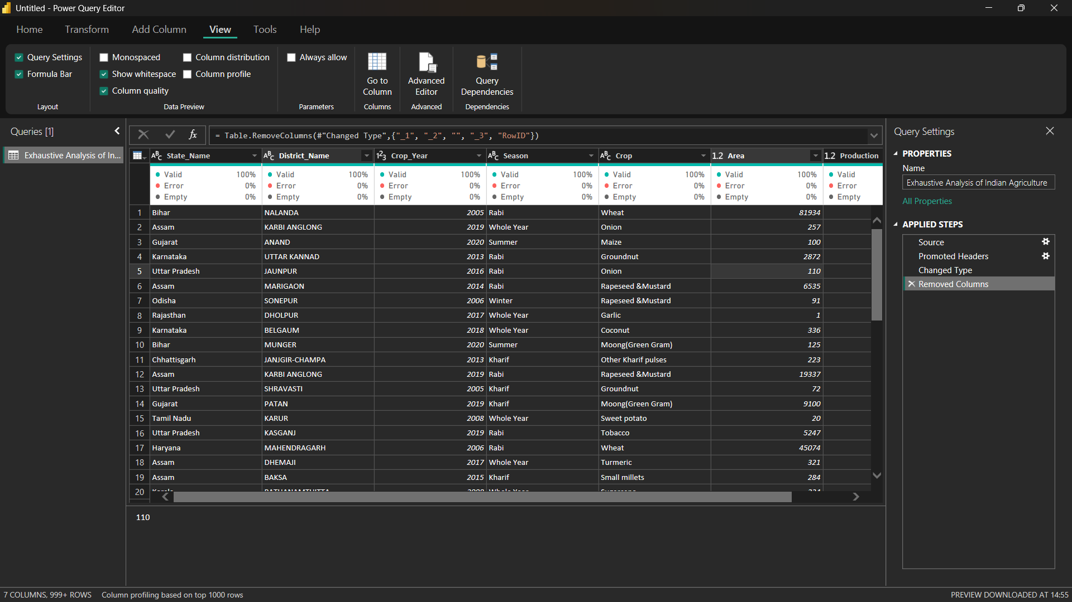

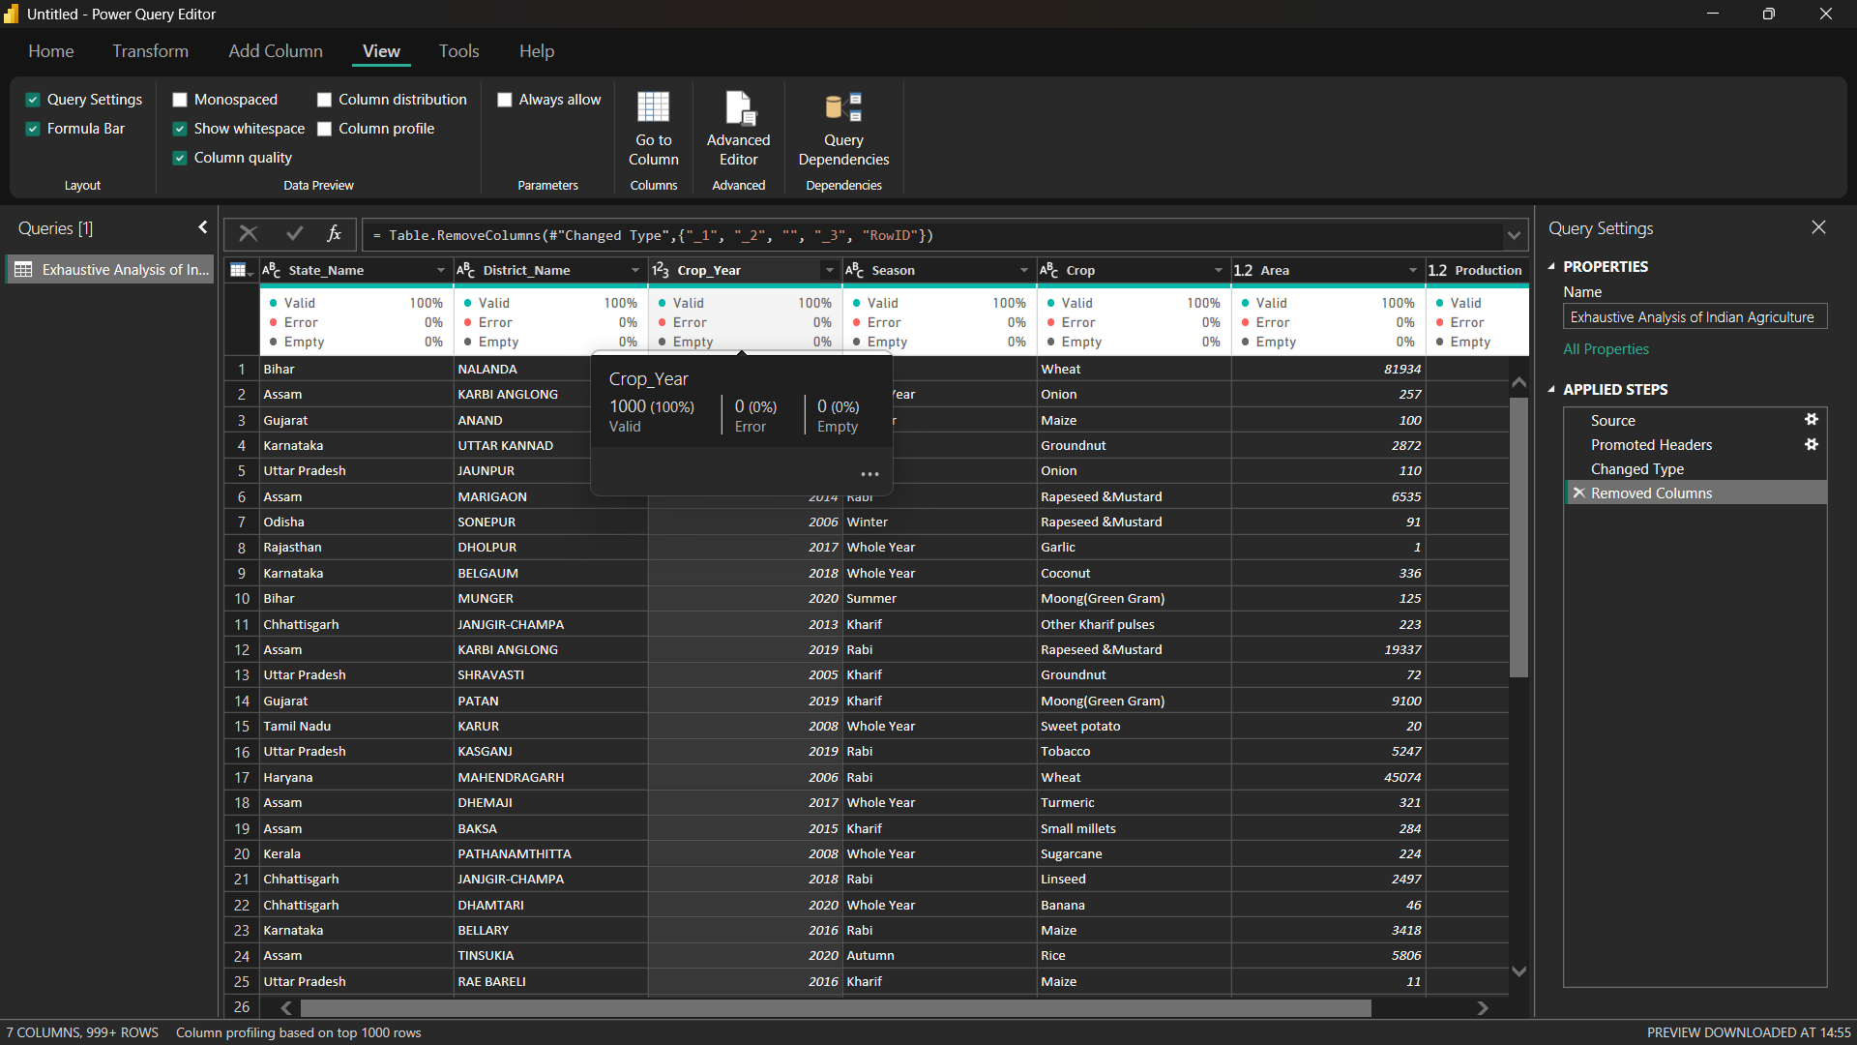

**Step 6 :-** Removing Blank Rows.

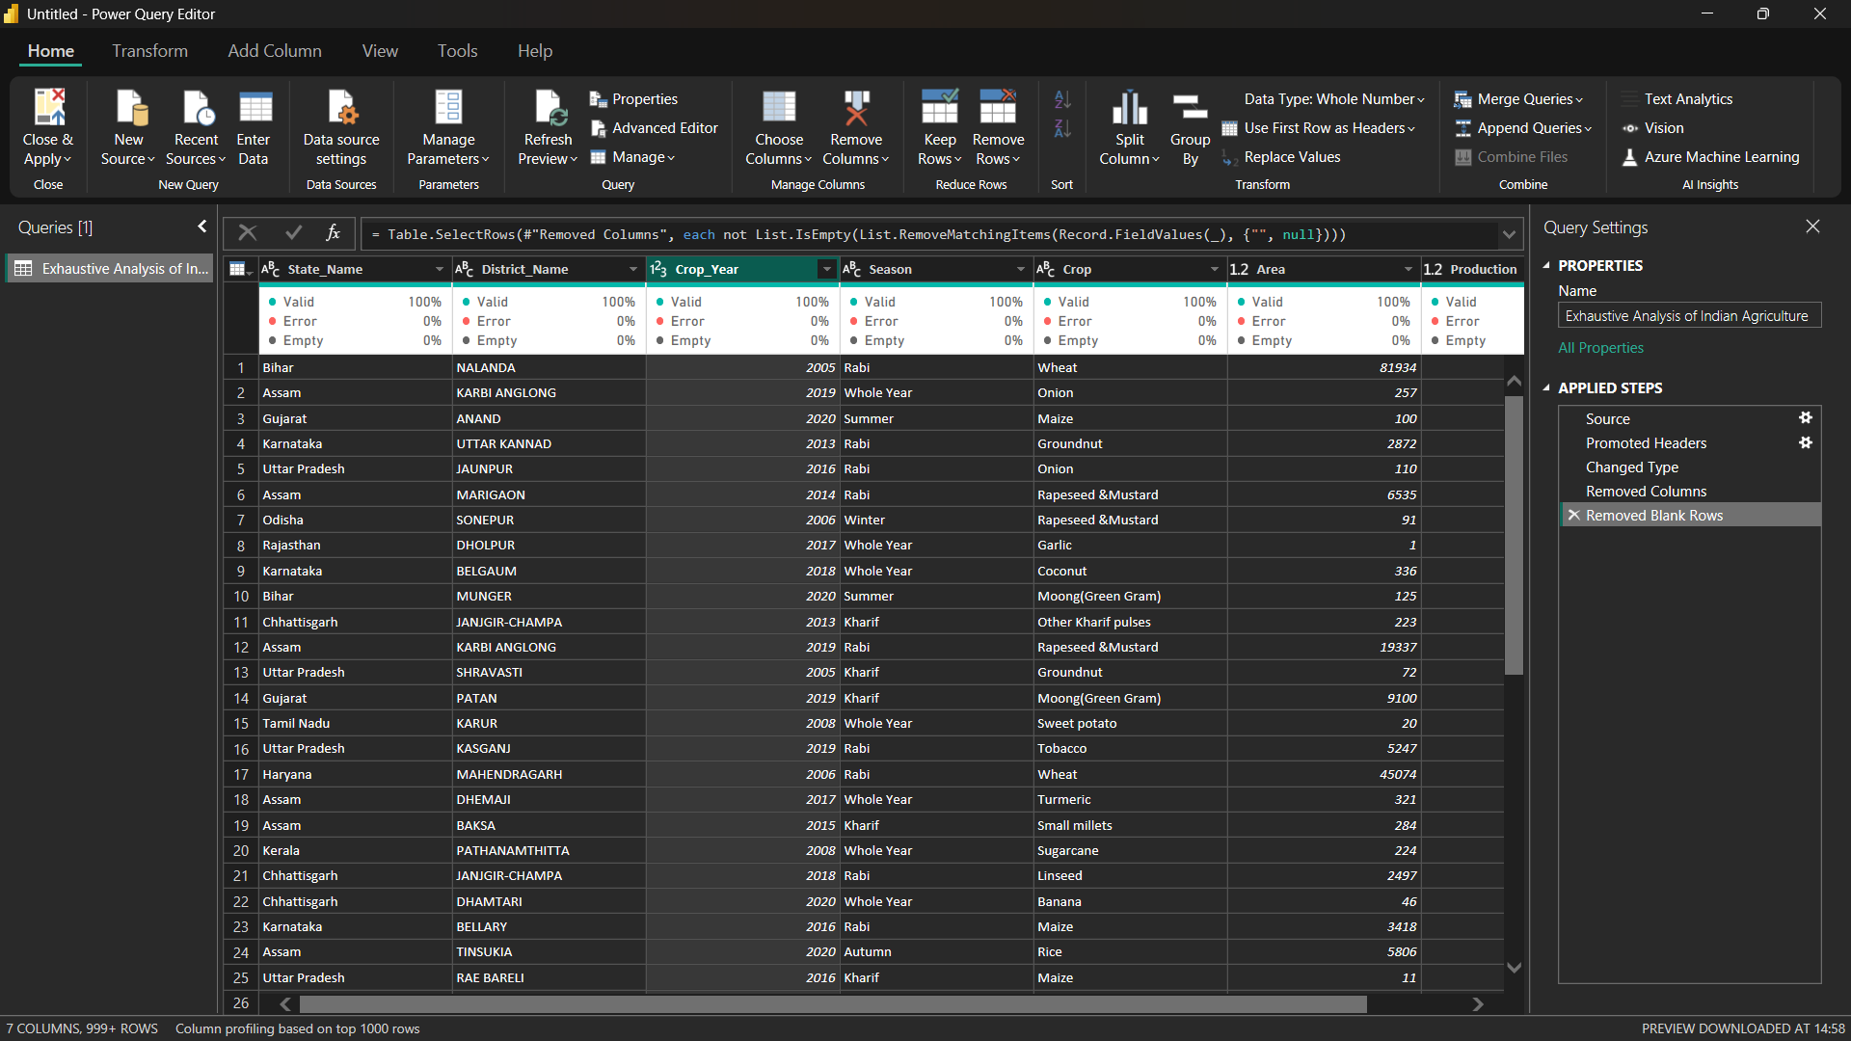

**Step 7:-** Removing Duplicate Rows.

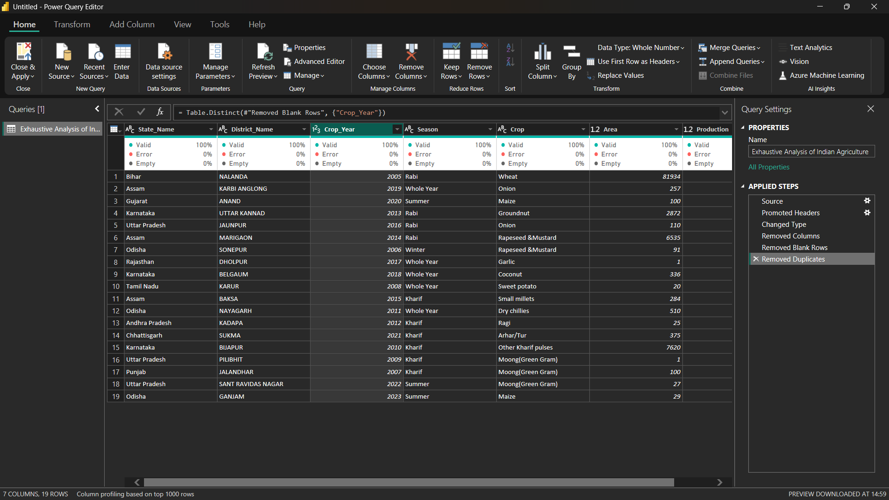

**Step 8 :-** Apply And Close .

